On The Sizes of Extended Fibonacci Cubes
Vittorio Scarano
IEEE TRANSACTIONS ON PARALLEL AND DISTRIBUTED SYSTEM, VOL. 10, NO. 7, pp. 764-766, JULY 1999
Abstract
In this paper, we show how Extended Fibonacci Cubes can be seen as (Cartesian) product graphs whose components are hypercubes and Fibonacci Cubes. By exposing this property, we prove that there are no distinct Extended Fibonacci Cubes (except the trivial ones) with the same number of nodes.
- Introduction
The Fibonacci Cube is a particular subgraph of a hypercube and is based on Fibonacci Numbers. The Extended Fibonacci Cubes, has the additional characteristic of being available for a large number of sizes the allowing more chosices to build different systems while keeping all the favorable characteristics like regularity and fault tolerance.
- Extended Fibonacci Cubbes
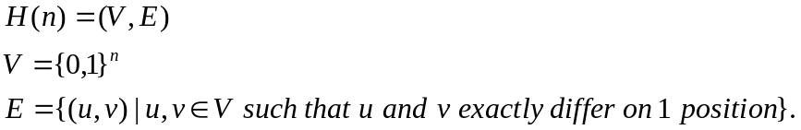
010||{00,01,10} = {01000,01001,01010}.
For any n≧2, we recursively define V(n)=0||V(n-1)∪10||V(n-2) where V(1) = {0,1} and V(0) = .
Definition 1. For any n≧2, the Fibonacci Cube of dimension n, denoted by FC(n) = (V(n), E(n)), is the subgraph of H(n-2) induced by V(n-2)
Given k≧0, for any n≧2 we recursively define 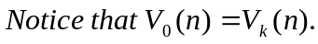
Definition 2. For any k≧0 and n≧k+2, the Extended Fibonacci Cube of order k and dimension n, denoted by 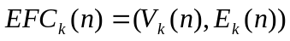, is the subgraph of 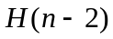 induced by 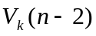.

- Sparsity of Extended Fibonacci Cubes
Theorem 3. An Extended Fibonacci Cube 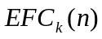 is the product graph: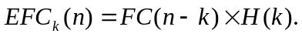
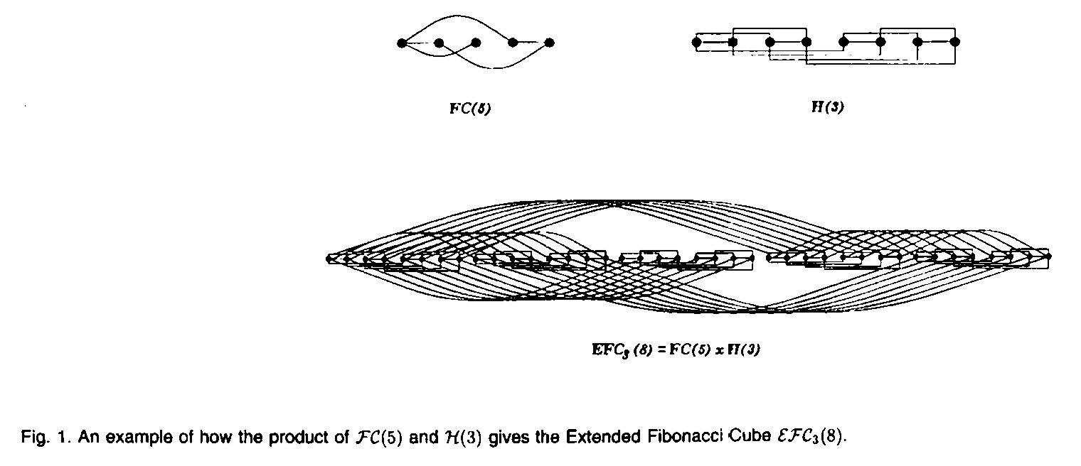
Corollary 4. The cardinality of is :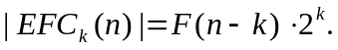
Theorem 5. The nontrivial Extended Fibonacci Cubes have all different sizes.
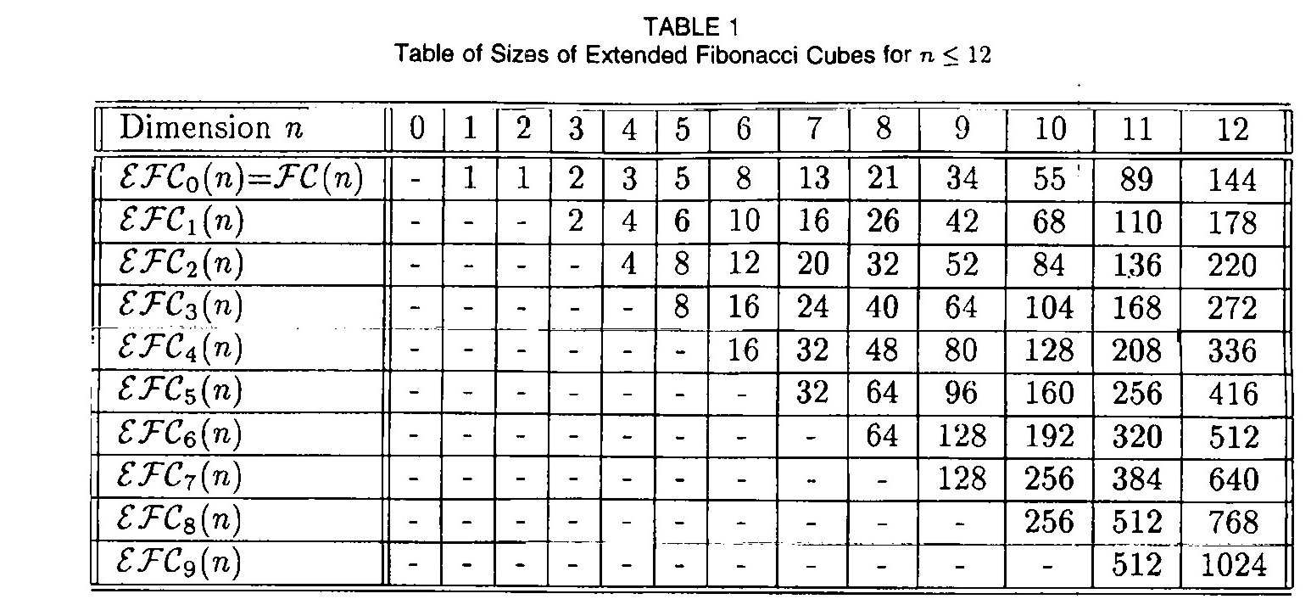
- Conclusions
Created by : Chia-Mao Huang
Date : Dec. 31, 1999

